Customer Shopping Behavior Analysis

1. Project Overview
This project analyzes customer shopping behavior using transactional data from 3,900
purchases across various product categories. The goal is to uncover insights into spending patterns, customer segments, product preferences, and subscription behavior to guide strategic business decisions.

2. Dataset Summary
- Total number of Rows: 3,900
- Total number of Columns: 18
- Key Features of the data:
- Customer demographics (Age, Gender, Location, Subscription Status)
- Purchase details (Item Purchased, Category, Purchase Amount, Season, Size, Color)
- Shopping behavior (Discount Applied, Promo Code Used, Previous Purchases, Frequency of Purchases, Review Rating, Shipping Type)
- Count of missing Data: 37 values in Review Rating column

3. Exploratory Data Analysis using Python
The following defines the steps performed during the with data preparation and cleaning in Python:
- Data Loading: Imported the dataset using pandas.
- Initial Exploration: Used df.head() to get an overview of the concerned data.
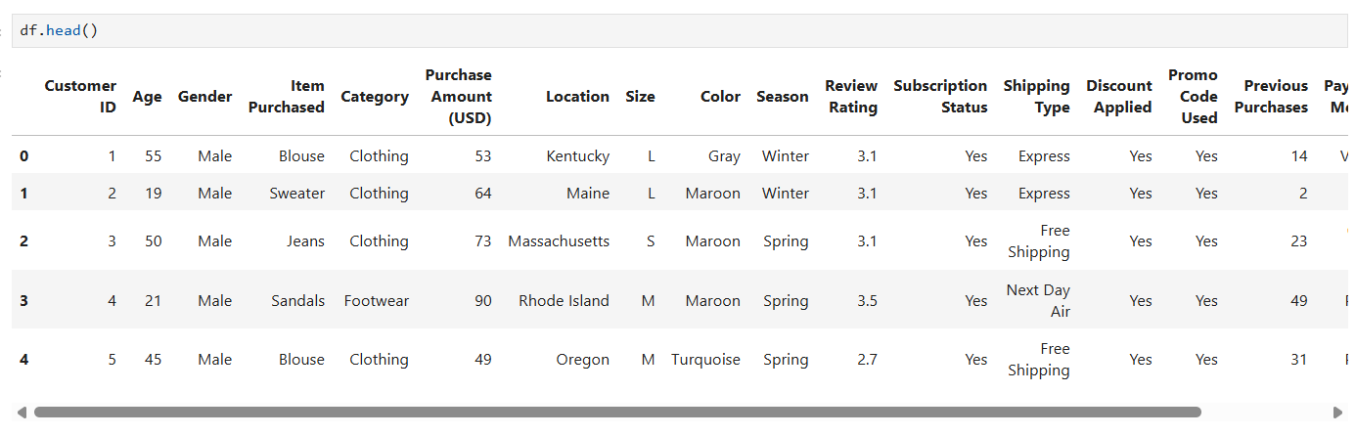

- df.info() to check structure of the data and the field types to verify the use of proper types in every column.
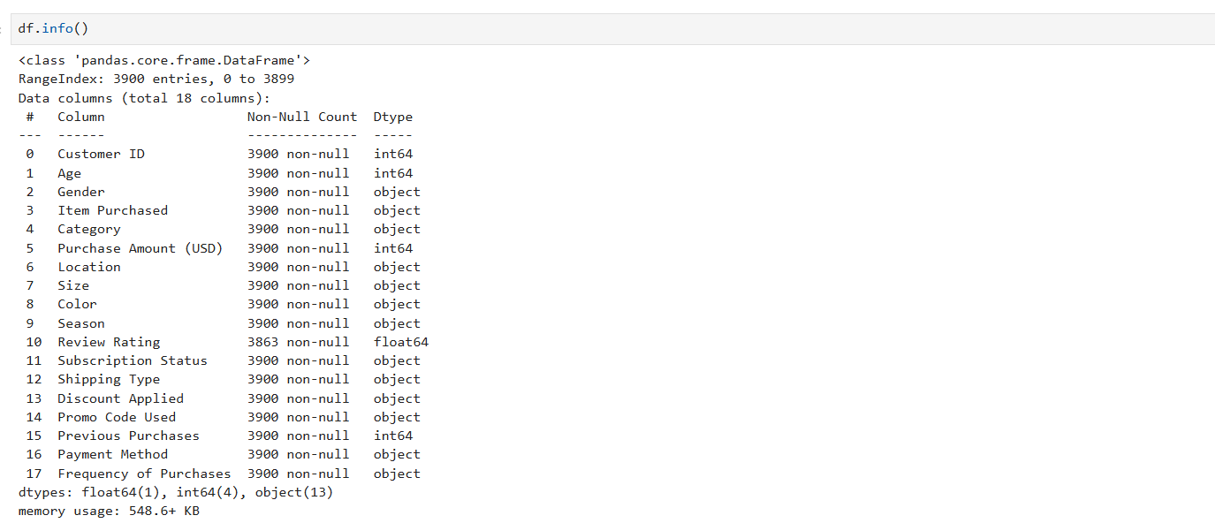

- df.describe() for summary statistics.
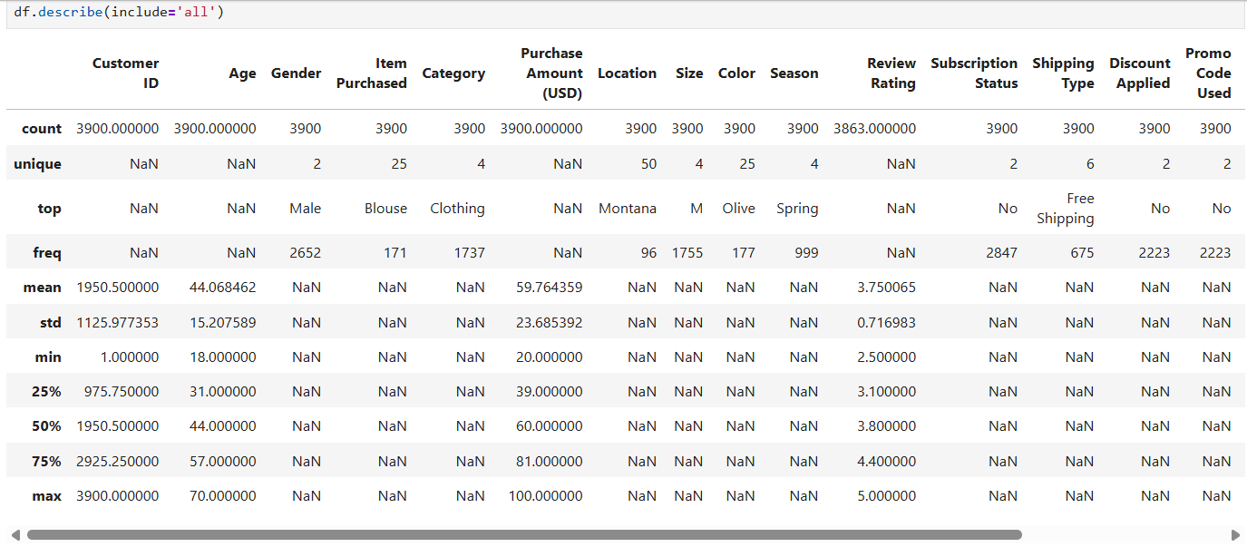

- Missing Data Handling: Checked for null values and imputed missing values in the
Review Rating column using the median rating of each product category.
- Column Standardization: Renamed columns to snake case for better readability and documentation.
- Feature Engineering:
  - Created age_group column by binning customer ages.
  - Created purchase_frequency_days column from purchase data.
- Data Consistency Check: Found that discount_applied and promo_code_used
were redundant columns; hence dropped promo_code_used.
- Database Integration: Connected Python script to PostgreSQL and loaded the cleaned DataFrame into the database for SQL analysis.

4. Data Analysis using SQL (Business Transactions)
Performed structured analysis in PostgreSQL to answer key business questions:
1. Revenue and Order Summary by Gender – Compared total revenue generated by male vs. female
customers.
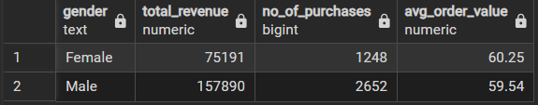
Findings: Male customers purchase more than females while the avg order value is fairly the same.

2. High-Spending Discount Users – Identified high spending discount loving customers who used discounts but still spent above the average purchase amount.
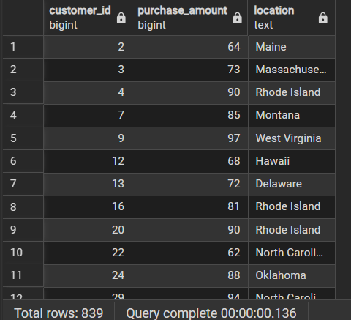
Findings: Found customers who spend more when given discounts.
3. Top Rated Products – Found products with the highest average review ratings within each category and also checked if they are the top selling products.
Top Selling products: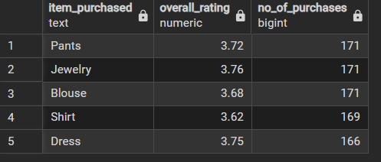
Top Rated Products:
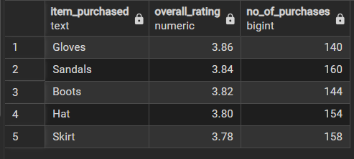
Findings: The top rated products are not the top selling products however the top selling products also have fairly high ratings.

4. Comparing Shipping Options – Compared average purchase amounts between Standard and Express shipping.
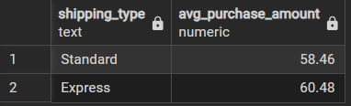
Findings: The avg order value is slightly higher with the express shipping option.

5. Subscribers vs. Non-Subscribers – Compared average spend and total revenue between Subscribers and Non-Subscribers.
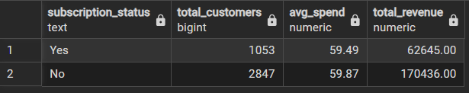
Findings: 27% of the customers have subscribed , the average order value is almost same among Subscribers and Non-Subscribers with the subscriber having slightly lesser avg order value. Subscribers have 26.88% contribution in the total revenue which is almost same as the percentage of subscribers among the customers.

6. Discount-Dependent Products – Identified products with the highest percentage of discounted purchases.
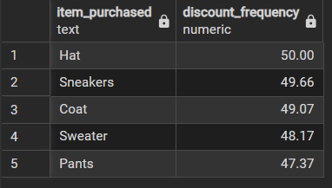
Findings: Found the products that heavily rely on the discounts for their sale.

7. Customer Segmentation – Classified customers into categories such as New, Returning, and Loyal segments based on purchase history.
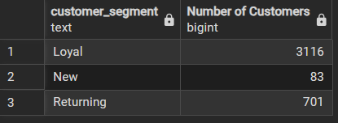
Findings: A large number of customers are loyal to the platform and we have a good number of returning customers. And the customer base is growing as the platform has some new customers as well.

8. Top Selling Products per Category – Listed 3 products with highest number of purchases within each category.
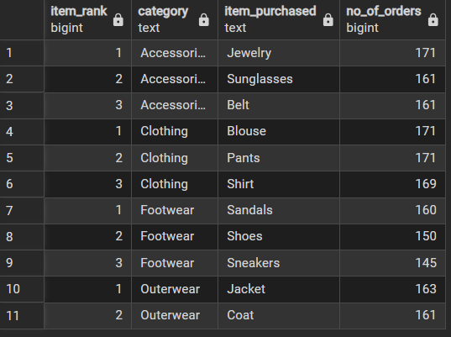
Findings: Found top 3 highest selling products in each category.

9. Repeat Buyers & Subscriptions Trend– Compared purchase history and subscription status to determine whether customers with more than 5 purchases are more likely to subscribe.
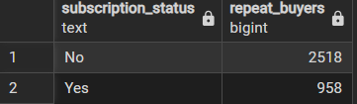
Findings: Our loyal customers are not subscribing as only 27.6% of our loyal customers have subscribed.

10. Revenue Segmentation by Age Group – Calculated total revenue contribution of each age group.
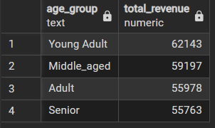
Findings: The ‘Young Adult’ section of our customer is the most active on our platform with the highest contribution in the revenue whereas the seniors have the smallest contribution among all the age groups. However the difference between the biggest and the smallest contribution is only $6380 where the largest contribution of ‘Young adult section is only 11.44% more than the seniors .
5. Dashboard in Power BI
Built an interactive dashboard in Power BI to present insights visually. Used cards to represent the important numbers like the number of customers, average purchase amount, average review rating , total revenue.
Created charts to show the distribution of revenue, no. of sales across categories.
Added slicers to change the parameters for an interactive dashboard for better analysis. 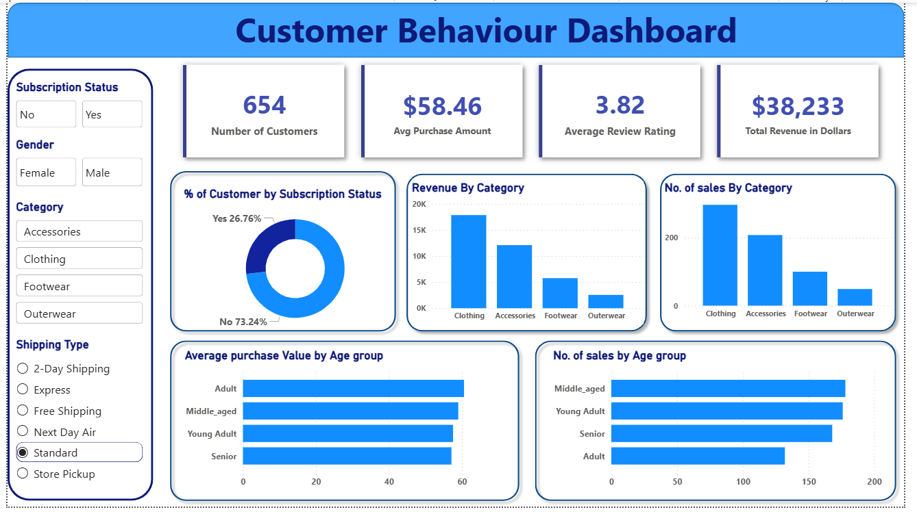
6. Business Recommendations
● Boost Subscriptions – Promote exclusive benefits for subscribers to drive subscriptions.
● Customer Loyalty Programs – Reward repeat buyers to move them into the “Loyal” segment.
● Review Discount Policy – Balance sales boosts with margin control.
● Product Positioning – Highlight top-rated and best-selling products in campaigns to drive their sales.
● Targeted Marketing – Focus efforts on high-revenue age groups ( Young Adults) also target females to drive to acquire new female customers .
● Focus on express-shipping methods to drive the average order value. .

